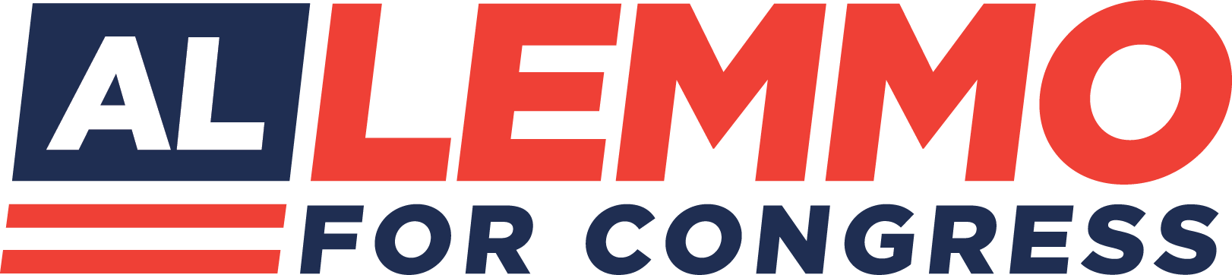

Privacy Policy

Lemmo for Congress
We understand the importance of protecting your personal information. This Privacy Policy describes how we collect, use, and disclose your personal information when you use our website. By using our website, you consent to the collection and use of your personal information as described in this Privacy Policy.

Collection of Personal Information
When you visit our website, we may collect certain personal information from you, including your name, email address, phone number, and other contact information. We may also collect other information about your usage of our website, such as your IP address, browser type, and operating system.

Use of Personal Information

We may use your personal information to:

• Provide and improve our website and services
• Respond to your inquiries and requests
• Communicate with you about our services, promotions, and events
• Personalize your experience on our website
• Analyze and monitor usage of our website
• Comply with legal obligations
• Disclosure of Personal Information

We may disclose your personal information to third-party service providers who assist us in providing our services, such as hosting providers, payment processors, and analytics providers. We may also disclose your personal information if required by law or to protect our legal rights. You agree not to use a false or misleading name or a name that you are not authorized to use. If in our sole discretion, we believe that any such information is untrue, inaccurate, or incomplete, or you have
opted into a Program for an ulterior purpose, we may refuse you access to the Program and pursue any appropriate legal remedies.

EXCEPT AS SET FORTH IN THIS SECTION, WE DO NOT SELL, RENT, LOAN, TRADE, LEASE OR OTHERWISE TRANSFER FOR PROFIT ANY PHONE NUMBERS OR CUSTOMER INFORMATION COLLECTED THROUGH PROGRAMS TO ANY THIRD PARTY

Cookies and Other Tracking Technologies
We may use cookies and other tracking technologies to collect information about your usage of our website and to personalize your experience. You can choose to accept or decline cookies. If you decline cookies, some features of our website may not be available to you.

Security of Personal Information
We take reasonable measures to protect your personal information from unauthorized access, disclosure, and use. However, no security measures are perfect, and we cannot guarantee the security of your personal information.

Children's Privacy
Our website is not intended for children under the age of 13, and we do not knowingly collect personal information from children under the age of 13. If we become aware that we have collected personal information from a child under the age of 13, we will take steps to delete the information as soon as possible.

Changes to this Privacy Policy
We may update this Privacy Policy from time to time by posting a new version on our website. We encourage you to review this Privacy Policy periodically. This Privacy Policy is strictly limited to these Programs and has no effect on any other privacy policy(ies) that may govern the relationship between you and us in other contexts.

